**One of the top most leading Private University in Uttar Pradesh (UP) India**

**Shri Venkateshwara University, Gajraula**

**About Us:**

The epitome of individuals who are dedicated to the cause of human welfare is education. No organization can succeed without commitment, because empathy is the source of dedication. Only sensitive people are capable of nurturing institutions that are dedicated to serving humanity. [**Shri Venkateshwara University, Gajraula**](https://svu.edu.in/), is one such institution. Shri Venkateshwara University (SVU), Gajraula is a State Private University established by Act No. 26 of 2010 of the Uttar Pradesh State Legislature and notified by the University Grants Commission under Section 2 (f) of the University Grants Commission Act 1956. We confer degrees in accordance with Section 22 (1) of the UGC Act 1956.

The university's state-of-the-art infrastructure, which includes laboratories and workshops for complete learning, provides exceptional teaching and research facilities. The University Grants Commission (UGC), the Pharmacy Council of India (PCI), the Bar Council of India (BCI), and the Indian Nursing Council (INC) have all given their approval for the university to operate various programmes. Dr. Sudhir Giri's flawless efforts are responsible for SVU's outstanding victory.

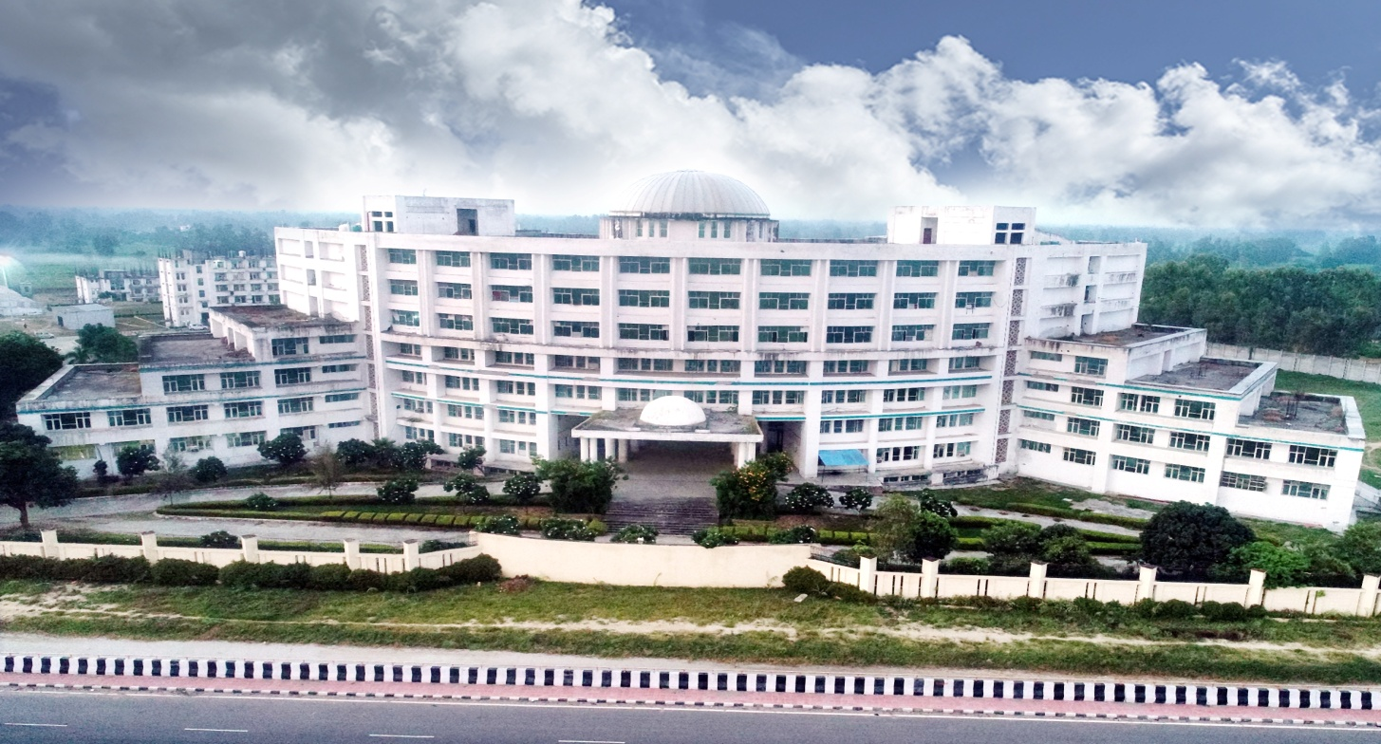

**Achievements:**

Her Majesty, At a virtual conference hosted at CCS University, Anandi Ben Patel, Governor of Uttar Pradesh, honored [**Dr. Sudhir Giri**](https://www.drsudhirgiri.com) for his outstanding contributions to healthcare and education (formerly Meerut University). He was honored for his outstanding performance in treating corona patients at their medical college and university. The governor expressed her pride in honoring such institutions and the individuals who run them.

Not only that, but he also got the Medical Excellence Award 2021 for ensuring the best possible recovery during Corona's first wave. Dr. Sudhir Giri's strong leadership made all of this possible. He dedicated this prize to the Venkateshwara group's dedicated team of doctors, paramedics, and nursing personnel, who treated the COVID patients day and night to ensure their quick recovery. On receiving the award, Dr. Sudhir Giri stated that unselfish devotion, dedication, and teamwork are the qualities that lead to success and respect.

Dr. Rajeev Tyagi, Pro-Chancellor of Shri Venkateshwara University, declared that the Venkateshwara Group will be among the top institutions in the country in the next decade due to Dr. Sudhir Giri's visionary thinking, vision, and outstanding education.

[**Dr. Sudhir Giri**](https://svu.edu.in/chancellor-message.php) had already received the International Glory Man of the Year Award 2021, as well as a half-dozen other accolades, for his outstanding work in rescuing thousands of patients during the crisis. Dr. Sudhir Giri was awarded the renowned 'Bharat Gaurav' for his outstanding contributions to healthcare and education for impoverished children by Vikramshila Hindi Vidyapeeth, the countries oldest serving organization. Dr. Sudhir Giri created SVU among India's Top Private Universities as a man, a visionary, and an educationist with an aim to develop rural young through inexpensive and contemporary education. SVU is the [**Best Private University in India**](https://svu.edu.in/), with state-of-the-art infrastructure that includes contemporary labs and workshops that foster a culture of research and innovation.

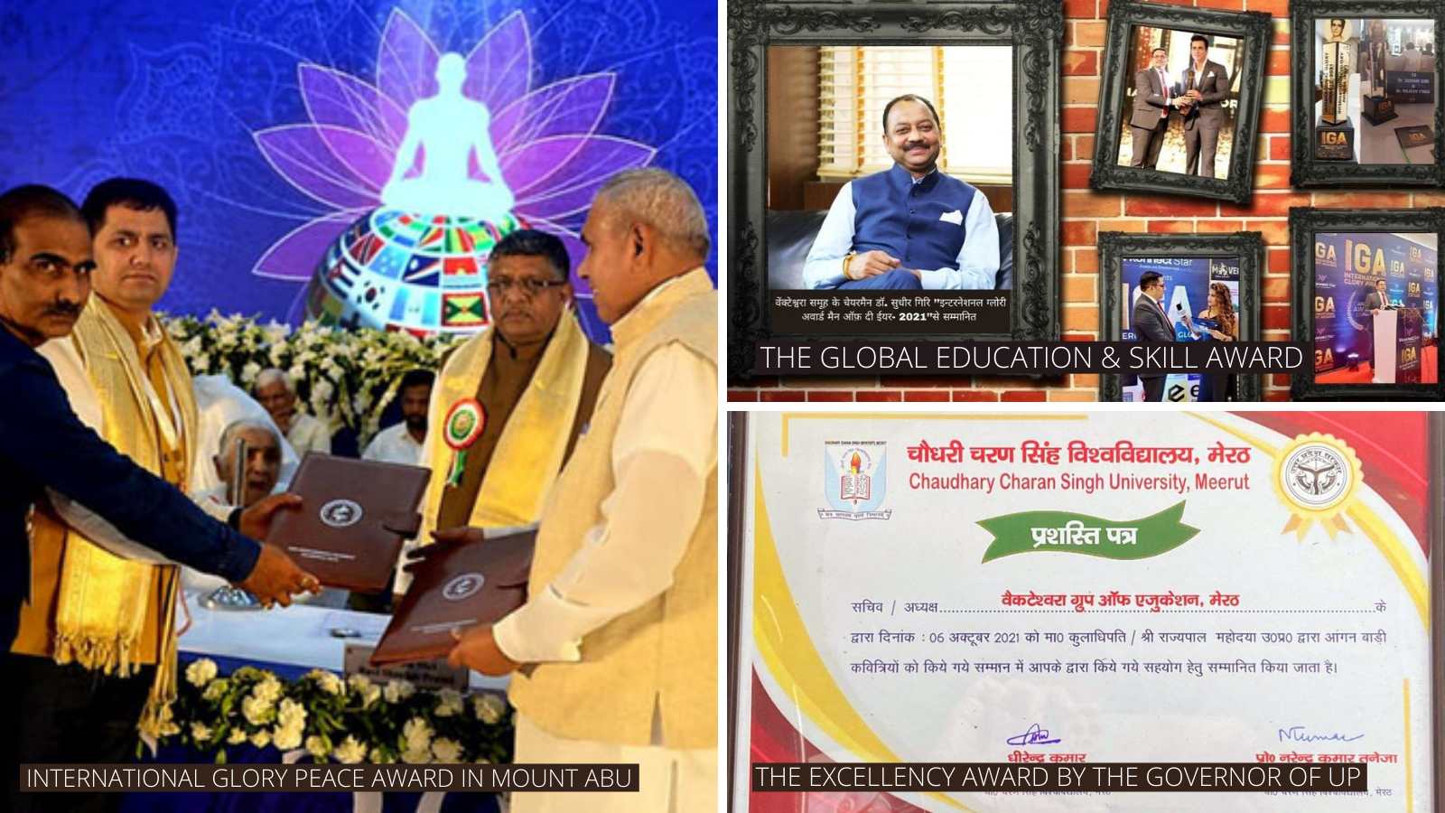

**Facilities:**

The computing laboratories, which are equipped with Intel equipment, provide the ideal environment for honing coding abilities, making us India's top private institution. With over 7000 volumes and e-resources, the library is the ideal learning environment. We have set up workshops in collaboration with industry to provide the necessary skills that have helped us become India's best private university. The university is located on NH 24 and is well connected by train and road, making it convenient to commute to campus. Each department has its own workshop and laboratory to guarantee that students perfect their talents, making us India's best institution.

**About Students and Faculty Members:**

Students and faculty are pushing themselves to new heights in the quest of excellence. As a result, we experience stress in our daily lives. In today's world, stress-related issues are on the rise. This is something we're addressing with our newly established School of Yoga Sciences. The Yoga school offers professional training as well as yoga sessions for students and employees. People participate in these sessions to relieve stress, making us India's best university. The lecture halls are packed with symposiums aimed at evaluating new talents, making us India's best private institution.

The faculties of SVU are a source of pride for the university. We hired them from IITs, NITs, and central universities to help our kids learn more effectively. The faculty aspires for research-based learning through practical experience, which has helped us become India's top institution. The vast majority are doctorates who have perfected their abilities via practice and demonstration. We send them on FDP to improve their skill sets, making us India's best private institution. Trainers in Python Blockchain have been hired by SVU. The most in-demand talents include AWS, Data Science, and deep learning.

These instructors have years of industry expertise, which is critical for conveying important skills, making us India's best institution. An internship is included in the curriculum to prepare students for employment. Students acquire valuable hands-on experience for job placement by learning topics in companies. For the internships of the students, we have partnered with notable companies. Because of our training, we are able to position the majority of them during internships, making us India's best private institution.

For those who can arrange it on their own, the internship is optional. SVU organizes internship opportunities for the rest of the students, which have played a vital part in their placement. The course curriculum at SVU is groundbreaking. In collaboration with industry organizations, we developed an industry-ready curriculum. This manner, we can teach what employers want, and our students will be job-ready. Students are upskilled in new technologies, allowing them to be placed, making us India's top institution. Students are actively involved in the learning process through role-plays, projects, and presentations.

Students participate in the learning process in labs by creating projects, models, and demonstrations, making us India's best private institution. Student participation is critical in the learning process because it allows them to obtain understanding that is necessary for job success. The workshop managers assist students in gaining skills that help them polish their knowledge, making us [**India's Best Private University**](https://svu.edu.in/).

SVU is dedicated to the pupils' complete growth. The cultural club hosts dance, drama, and fashion shows in which students can show off their skills. The faculty encourages them to participate and develop their personalities, making us India's best private institution. The sports committee guarantees that pupils participate in games and develop a full personality. We provide a sports field and game infrastructure that encourages students to participate and stay healthy. We host an annual sports week that draws athletes from top universities. Our students have received numerous awards in state and national competitions, making us the leading institution in Uttar Pradesh, India.

They are trained by a staff of qualified coaches who aspire for greatness in a variety of international competitions. We urge them to participate in games that will help them focus on their studies, making us [**Top Private University in India**](https://svu.edu.in/).

**Programs We Provide:**

* Institute of Medical Sciences
* [School of Paramedical Sciences](https://svu.edu.in/institute-of-paramedical-sciences.php)
* [School of Pharmaceutical Sciences](https://svu.edu.in/school-of-pharmaceutical-sciences.php)
* [School of Nursing](https://svu.edu.in/school-of-nursing.php)
* [School of Applied Sciences](https://svu.edu.in/school-of-applied-sciences.php)
* [School of Commerce & Management](https://svu.edu.in/school-of-commerce-&-management.php)
* [School of Agricultural Sciences](https://svu.edu.in/school-of-agricultural-sciences.php)
* [School of Engineering & Technology](https://svu.edu.in/school-of-engineering-technology.php)
* [School of Humanities, Languages & Social Sciences](https://svu.edu.in/school-of-human-languages-social-sciences.php)
* [School of Education](https://svu.edu.in/school-of-education.php)
* [School of Library & Information Sciences](https://svu.edu.in/school-of-library-information-sciences.php)
* [School of Law & Jurisprudence](https://svu.edu.in/school-of-law-jurisprudence.php)
* [School of Design](https://svu.edu.in/school-of-design.php)
* [School of Mass Communication](https://svu.edu.in/school-of-mass-communication.php)
* [School of Yoga](https://svu.edu.in/school-of-yoga.php)
* [School of Real Estate Management](https://svu.edu.in/school-of-Real%20Estate%20Management.php)

Our unique integrated courses, state-of-the-art facilities and laboratories, most enriching global exposure with an elite league of faculties, and experts from the finest IITs and NITs guarantee an added advantage of pure excellence to the students at SVU [**Best Private University in Uttar Pradesh (UP)**](https://svu.edu.in/).

**Infrastructure:**

A magnificent green backdrop of 60 acres provides the ideal setting for our peaceful, pleasant, and pollution-free educational campus. We have digital classrooms, a library, a bank ATM, a gym, an ac auditorium, and sophisticated laboratories to offer optimum study, health, and convenience for our students. India's Best Private University.

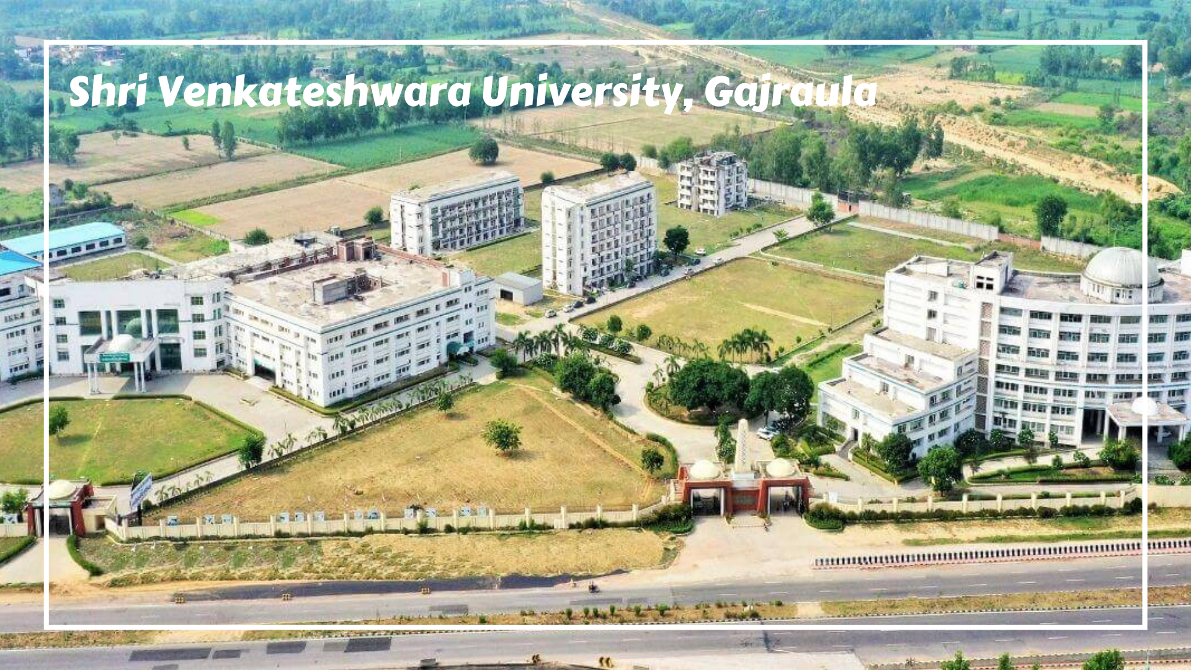

**Placements and Internships:**

At SVU, we work closely with our students to help them find internships and jobs that will help them advance in their careers. Our placement team is always committed to giving our students with the necessary training and support to help them navigate the competition in their fields.

**Our Vision:**

To be a world-class academic centre with cutting-edge facilities and cutting-edge educational resources for research-based activities, innovative teaching methods, and a stimulating learning environment. To be recognized as a high-quality research centre by recognizing and nurturing talent for knowledge development while balancing personal and professional excellence.

**Our Mission:**

In order to attain success in the International Palaestra, knowledge must be conveyed. Facilitating the integration of multidisciplinary tools, techniques, and approaches for enrichment and quality enhancement in order to carry out the purpose of developing high-quality human assets to meet the world's rising needs.